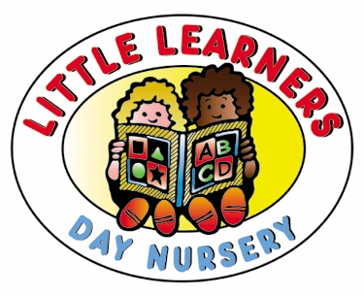

30 Hours Code Form

Dear Parents,

Can you please let us know the following details to check 30 hours code?

Please note your child name should be the same as in Birth Certificate.

Child’s First Name:

Child Last Name:

Child’s DOB(DD/MM/YYYY):

Parent Details (Please write the parent NI number and other parent details you used to get the 30 hours code from the government website).

Parent First Name:

Parent Last Name:

Parent DOB (DD/MM/YYYY):

Parent National Insurance Number :

Reference Number (30 Hours Code):

Branch Applied For:

Once we check 30 hours code, and if the code is valid, we will let you know our availability and send you the acceptance letter.

Kind Regards,
Funding.

